How to setup svn server

1. Download svn server [Setup-Subversion-1.6.5.msi] and svn client[TortoiseSVN-1.6.6.17493-win32-svn-1.6.6.msi]

And install them.

1. Create the svn repository.

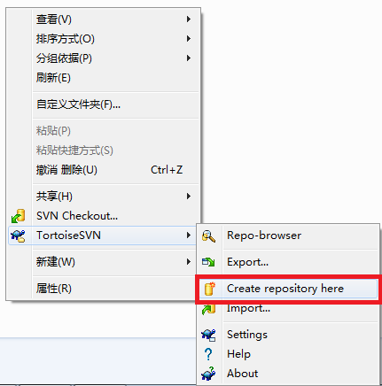

Then you can see below folds are created



1. Open folder conf and configure below three files in repository

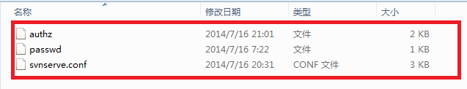for svnserve.conf

Uncomment below two lines

password-db = passwd

authz-db = authz

for passwd add configuration

xiao=xiao

for authz add below configuration

[/]

xiao=rw

1. Invoke svnserve.exe in the server bin directory.

Note: D:\svn_respository is the svn repository in your local.

